My holiday
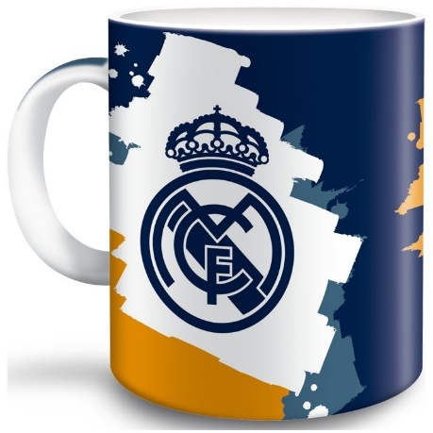
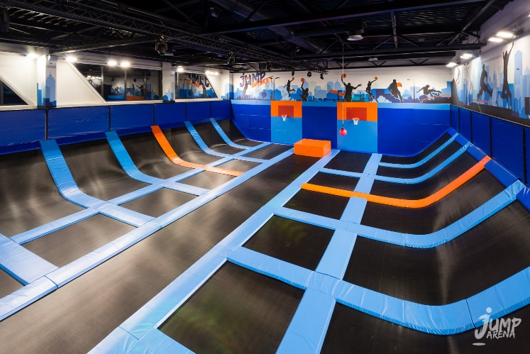
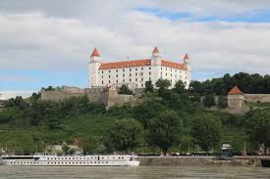
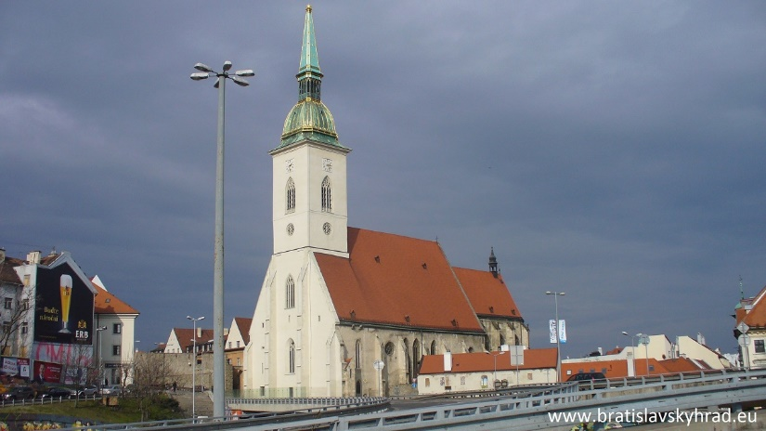
I spent my last winter holiday in the capital city of Slovakia, Bratislava. I was there with my family because my brother studies there. I went to Jump Arena. I jumped on the trampolines for an hour. It was fun. Later we played a Laser game. There I hurt my ankle. Then my brother showed us his university and school dorm, where he lives. The next day we visited St Martin´s Cathedral and Bratislava Castle. We also went to the square because there were Christmas markets. I bought a Real Madrid mug. The whole trip we slept in a hotel near the center.

