Počítame do 8 Meno: ...............................................................

1.Doplň čísla v rozklade:

|  |  |  |  |  |  |  |  |  |  |  |  |  |  |
| --- | --- | --- | --- | --- | --- | --- | --- | --- | --- | --- | --- | --- | --- |
| 8 | | 8 | | 8 | | 8 | | 8 | | 8 | | 8 | |
| 2 |  | 7 |  | 4 |  | 3 |  | 1 |  | 5 |  | 6 |  |

2. Doplň chýbajúce znamienko + alebo -:

|  |  |  |  |  |  |  |  |  |  |  |  |  |  |  |  |  |
| --- | --- | --- | --- | --- | --- | --- | --- | --- | --- | --- | --- | --- | --- | --- | --- | --- |
| 8 |  | 1 | = | 7 |  | 7 |  | 5 | = | 2 |  | 3 |  | 5 | = | 8 |

|  |  |  |  |  |  |  |  |  |  |  |  |  |  |  |  |  |
| --- | --- | --- | --- | --- | --- | --- | --- | --- | --- | --- | --- | --- | --- | --- | --- | --- |
| 2 |  | 6 | = | 8 |  | 6 |  | 3 | = | 3 |  | 6 |  | 4 | = | 2 |

3. Vypočítaj retiazkové príklady:

5 + 3 – 4 + 3 – 1 + 2 = 8 – 6 + 3 + 2 – 1 – 2 + 4 =

4. Šmolko rád kreslí. Má 8 pasteliek, ale 2 z nich sú tupé. Koľko

pasteliek má na kreslenie?

5. Utvor príklady, ktorých súčet bude 8:



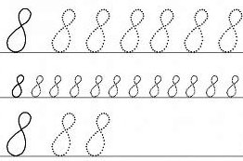

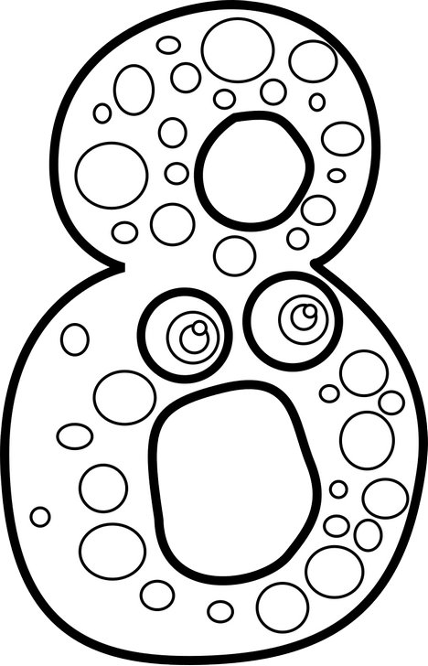



Šmolko má na kreslenie ..... pasteliek.

=

=

+

=

+

Počítame do 8 Meno: ...............................................................

1.Doplň čísla v rozklade:

|  |  |  |  |  |  |  |  |  |  |  |  |  |  |
| --- | --- | --- | --- | --- | --- | --- | --- | --- | --- | --- | --- | --- | --- |
| 8 | | 8 | | 8 | | 8 | | 8 | | 8 | | 8 | |
| 2 |  | 7 |  | 4 |  | 3 |  | 1 |  | 5 |  | 6 |  |

2. Doplň chýbajúce znamienko + alebo -:

|  |  |  |  |  |  |  |  |  |  |  |  |  |  |  |  |  |
| --- | --- | --- | --- | --- | --- | --- | --- | --- | --- | --- | --- | --- | --- | --- | --- | --- |
| 8 |  | 1 | = | 7 |  | 7 |  | 5 | = | 2 |  | 3 |  | 5 | = | 8 |

|  |  |  |  |  |  |  |  |  |  |  |  |  |  |  |  |  |
| --- | --- | --- | --- | --- | --- | --- | --- | --- | --- | --- | --- | --- | --- | --- | --- | --- |
| 2 |  | 6 | = | 8 |  | 6 |  | 3 | = | 3 |  | 6 |  | 4 | = | 2 |

3. Vypočítaj retiazkové príklady:

5 + 3 – 4 + 3 – 1 + 2 = 8 – 6 + 3 + 2 – 1 – 2 + 4 =

4. Šmolko rád kreslí. Má 8 pasteliek, ale 2 z nich sú tupé. Koľko

pasteliek má na kreslenie?

5. Utvor príklady, ktorých súčet bude 8:









Šmolko má na kreslenie ..... pasteliek.

=

+

=

+

=